16.07.2020
Lab-I - HTML Basic Tags, formatting and Tables

Design the sample web pages given below. Note: Only the Images used in the web pages should be taken (cut) using any image editing tools. All Background images/colour, text, text formatting, colour, link properties has to be applied accordingly given in the design.

1.
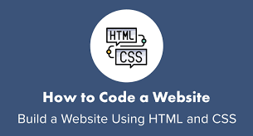

2.
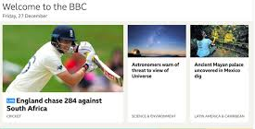

3.
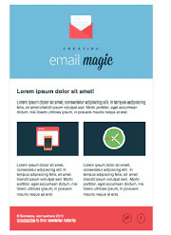
4.
